1. **Charter Schools are more successful in terms of overall passing (math’s/reading) compared to district school. This could be identified from the below trend**

Top 5 performing Schools

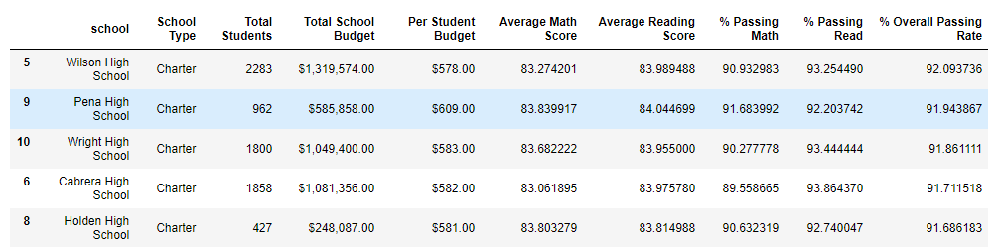 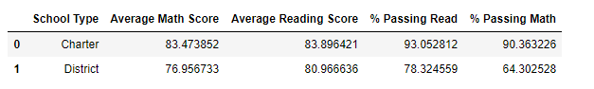

1. **Schools spending higher budget per student are less successful in terms of overall passing (math’s/reading) compared to the schools spending less per student**

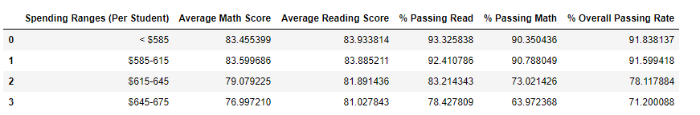

1. **Smaller the Size of the school better is the passing percentage in math’s/reading. Thus small/medium sized school perform much better than larger schools**

